<https://www.ecotic.es/en/252116/Waste.htm>

**ECOTIC**

[](https://plus.google.com/+FundacionECOTIC/posts?hl=es)[](http://www.linkedin.com/company/ecotic?trk=cws-cpw-coname-0-0)[](http://twitter.com/#!/FundacionECOTIC)[](http://www.youtube.com/user/FundacionECOTIC)

**Foundation Ecotic**

Our main activity is the proper management of waste electrical and electronic equipment (WEEE) companies and affiliated entities our Integrated Management System (SIG).

Principio del formulario

* [**What is WEEE?**](https://www.ecotic.es/en/252116/Waste.htm#a3013)
* [**The importance of recycling**](https://www.ecotic.es/en/252116/Waste.htm#a3019)
* [**Manegement of WEEE**](https://www.ecotic.es/en/252116/Waste.htm#a3020)
* [**Where is waste handed in?**](https://www.ecotic.es/en/252116/Waste.htm#a3018)
* [**Recycling technologies**](https://www.ecotic.es/en/252116/Waste.htm#a3021)

What is WEEE?

**WEEE** is defined as waste electrical and electronic equipment, materials, components, consumables and incorporated subassemblies from both private households and professional use. Also considered as such are devices for generating, transferring and measuring currents and fields.

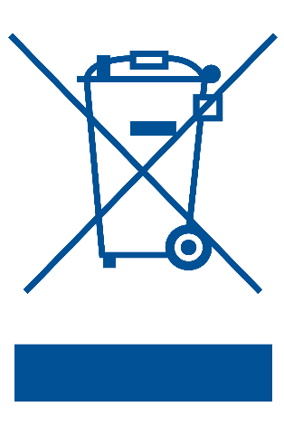

**All equipment should be marked with the symbol of a crossed-out wheeled bin** to inform consumers that it should not be thrown out with the household rubbish, but selectively recycled.

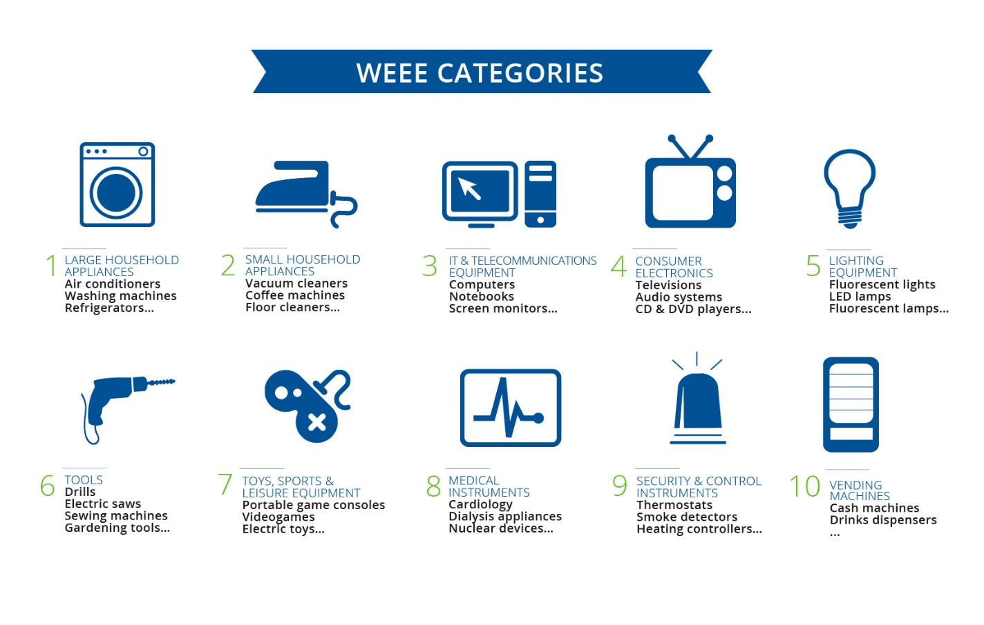

The importance of recycling

Today’s rapid evolution of technology has resulted in huge amounts of waste electrical and electronic equipment. Estimates suggest that **WEEE is currently growing at a rate 3 times higher than other municipal solid waste.**

In 2013, a report [**Solving the E-waste Problem (StEP) Initiative**](http://www.step-initiative.org/) (an association of UN organisations, industry, governments, scientists and NGOs) warned that WEEE had risen to nearly **49 million tonnes**, which would correspond to an average of **7 kilos for each of Earth’s 7 billion inhabitants**. In light of these data, it is not hard to get an idea of how important it is to recycle this waste.

From an environmental perspective, the best option for WEEE is **to repair and reuse** whenever possible, and prevent devices from becoming waste. This requires a system of logistics that allows the characteristics of the devices to be preserved through an appropriate system of collection, transportation, sorting and storage, to avoid any damage that would prevent reuse.

If this is not possible, waste must be disassembled or crushed for recycling. Using suitable processes, we can **recover and reuse the raw materials** contained in equipment. This enables us reintroducing these valuable materials into new industrial processes, **avoiding the depletion of finite natural resources.**

**"Recycling has gone from being a necessity for environmental conservation to a requirement for the sustainability of our economies"**

The main problem we face in managing waste is the presence of **potentially polluting substances if they do not undergo suitable decontamination processes** prior to processing in recycling plants. This includes refrigerants and oils contained in refrigerators and air conditioners, phosphor powder found in cathode ray tubes and batteries and condensers that can be found in other equipment, which may have an adverse impact on the environment and people’s health.

Manegement of WEEE

[**Royal Decree 110/2015**](http://www.boe.es/diario_boe/txt.php?id=BOE-A-2015-1762), of 25 February, regarding electrical and electronic equipment and waste management, incorporates European directives approved on this matter into national legislation, and establishes a series **of standards applicable to the manufacturing of products and the proper environmental management** when they become waste.

Royal Decree 110/2015 requires producers of electrical and electronic equipment to adopt necessary measures so that the waste products from these devices, placed onto the market by them, **have systems for selective collection and are properly manage from the environmental perspective**. These obligations can be met individually or through one or more Extended Producer Responsibility System (EPRS), as in the case of ECOTIC.

Similarly and beyond obligations on producers, the legislation establishes WEEE-related responsibilities that apply to distributors, public authorities and citizens, through which **the responsibility for the proper recycling of WEEE rests with each and every one of us.** Companies, authorities and consumers are key players in the recycling process, and it’s important that we're aware of our active role in securing the future of the environment.

Once collected, WEEE is channelled to different treatment plants depending on their specific needs; in general, though, they go through similar component-separation processes.

1. **Collection and transportation to the treatment plant.**
2. **Receipt and storage.**
3. **Classification of equipment.**
4. **Manual disassembly and separating out of hazardous components.**
5. **Breaking down of recoverable materials.**
6. **Separation of materials and shipping for external recovery**

**"At ECOTIC, we are working so that the economic resources provided by our partners in order to finance waste are used with maximum guarantees of efficiency and process quality"**

Further information on responsibilities regarding recycling can be found in our [***producers section***](http://www.ecotic.es/en/252115/Target-Markets.htm)*,* [***distributors section***](http://www.ecotic.es/en/252115/Target-Markets.htm#a3015) *and* [***installers section***](http://www.ecotic.es/en/252115/Target-Markets.htm#a3011)*, where further information can be found regarding the different features and services offered by ECOTIC to each of these groups.*

Where is waste handed in?

**End users of electrical and electronic equipment may dispose of waste products free of charge** by depositing them at Recycling Points or other areas designated for this purpose, or in shops that sell equipment when purchasing a new device.

Businesses must also accept small appliances of less than 20 cm size brought in by users, regardless of whether or not they purchase a new one.

The collection of WEEE is built around three basic collection and storage points.

* **Recycling Points and other municipal points,** where private users can bring their household waste.
* **Distribution company warehouses,** where waste generated by those distributors is stored.
* **Load Grouping Centres fitted out by ECOTIC** that accept WEEE from Recycling Points and distributors, before being transported to recycling companies.

From Recycling Points, distributors’ warehouses and Load Grouping Centres, the waste is transported by the logistics company to recycling companies that have suitable resources for treating it, depending on the specific characteristics of the different types of waste.

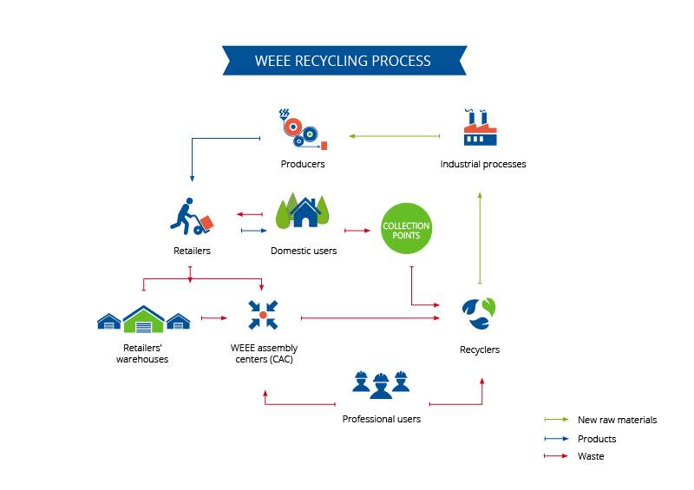

Recycling technologies

**The ultimate goal of managing WEEE is to convert it into new resources,** recovering the materials contained in electrical and electronic equipment so that it can be used again as part of a new value chain. Thus, the management of WEEE ensures the reuse of materials, while minimising the impact of waste on the environment and depletion of the planet’s natural resources.

Recovering these materials depends on the **ability to respond to the specific processing needs of different types of WEEE,** by applying different recycling methods in line with the particular idiosyncrasies of each waste item. There are primarily four methods used in recycling WEEE:

* **Manual disassembly and separation** of a device’s components.
* **Mechanical recycling,** by extracting and crushing materials.
* **Smelting,** to recover metals.
* **Chemical recycling,** applicable to precious metals (gold, silver, etc) contained in printed circuit boards.

To achieve this, beyond ensuring the proper channelling of WEEE, we need **to develop new technologies and improve processes**, as they have a direct impact on the recovery of materials and enable higher recovery rates to be achieved. At ECOTIC we are **committed to innovation: it is part of our DNA.** And we are working to meet new needs arising from rapid technological development.

  
  
In this respect, we actively participate in numerous initiatives such as the [**LIFE+ High Technology Waste Treatment (HTWT)**](http://www.htwt.eu/), which has successfully developed the **first industrial prototype for recycling LCD and plasma screens and photovoltaic solar panels,** avoiding the problems arising from processing this type of waste equipment.

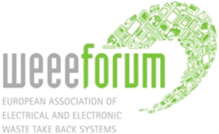

We are also partners of the [**WEEE Forum**](http://www.weee-forum.org/), an association of 42 WEEE collection and recovery systems at European level, which operates as a platform for cooperation and the exchange of good practice. The aim of the WEEE Forum is to develop standards and technical specifications to fulfil producers’ responsibilities and assist its members in working sustainably within the existing regulatory framework.

**Contents**

* [What is WEEE?](https://www.ecotic.es/en/252116/Waste.htm#a3013)
* [The importance of recycling](https://www.ecotic.es/en/252116/Waste.htm#a3019)
* [Manegement of WEEE](https://www.ecotic.es/en/252116/Waste.htm#a3020)
* [Where is waste handed in?](https://www.ecotic.es/en/252116/Waste.htm#a3018)
* [Recycling technologies](https://www.ecotic.es/en/252116/Waste.htm#a3021)  
  [**Site map**](https://www.ecotic.es/en/247021/Rewrite.htm)